
Company
Logotype

Cone Beam Computed Tomography- Report



Porur Dental X-rays & CBCT

Patient Name : Mrs. Nandhini | Date of Report : 06.05.2024
Age/ Gender : 36 years/ Female | Region of Interest : CBCT Sectional Mandible
Referring doctor: Dr. Siva Subramanian | Indication : Implant assessment
Clinical Notes: Nil
PATIENT INFORMATION

CBCT- Sectional Mandible provided
CBCT – IMAGE DETAILS

RADIOGRAPHIC INTERPRETATION

- In relation to the periapical aspect of the teeth 31, 32, presence of a single, diffuse hypodensity measuring 8.04 x 9.38 x 5.59mm in dimension with diffuse borders is evident.
- In relation to 31, 32, 41, 42 presence of bone loss extending upto the apical third of the teeth is evident (Floating teeth appearance in relation to 31).
- The alveolar bone in relation to the mandibular ridge is present with normal trabecular pattern.

IMPLANT ASSESSMENT

 | 31 region | 32 region | 41 region | 42 region
Sub-Crestal (in mm) | 5.84 | 6.7 | 4.83 | 6.17
Mid- Crestal (in mm) | 6.21 | 6.9 | 5.2 | 5.96
Distance between alveolar ridge and the inferior border of mandible (in mm) | 18.21 | 17.41 | 19.26 | 19.64

RADIOGRAPHIC IMPRESSION

- Periapical pathology in relation to 31, 32.
- Chronic periodontitis in relation to 31, 32, 41, 42.

Kindly correlate with clinical findings


IMAGES FOR REFERENCE

RECONSTRUCTED PANORAMIC VIEW

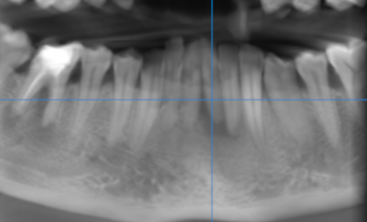

3-DIMENSIONAL VIEW

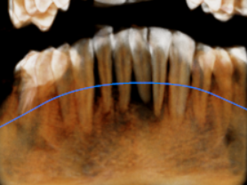

CROSS SECTIONAL VIEW

31 region | 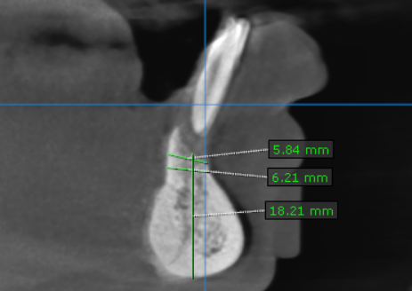
32 region | 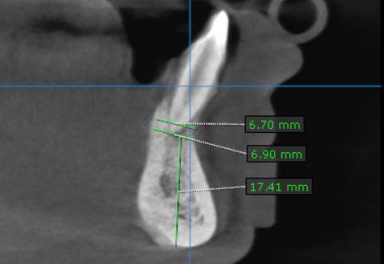
41 region | 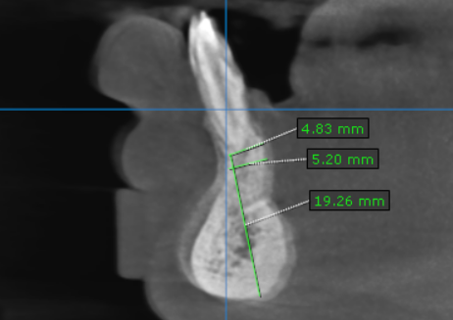
42 region | 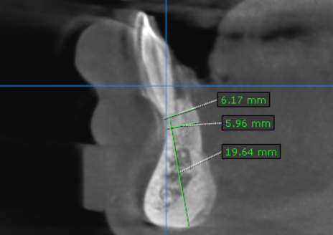

**** End of report ****

